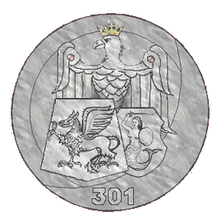

Squadron's commanders
27 July 1940 R.Rudkowski 27 July W.J. Piotrowski 2 Apr 1942 S. Krzystyniak 26 June 1942 M.L. Brzozowski 4 July 1942 H. Kolodziejek 26 Sep 1942 A. Dabrowa 20 Apr 1943 S. Krol 14 June 1944 E. Arciuszkiewicz.
Places of stationing
22 July 1940 Bramcote (Warwick) ► 29 Aug 1940 Swinderby (Linc.) ►18 July 1941 Hemswell (Linc.) ►19 Apr 1943 Tempsford ►Now 1943 Sidi Amor (Tunis) ►Dec 1943 Brindisi (Italy) ►Mar 1945 Blackbush.
Squadron's aircraft
22 July 1940 Fairey Battle Oct 1940 Wellington MkI June 1941 Wellington MkIV Apr 1943 Halifax and B-24Liberator Mar 1945 Warwick III Jan 1946 Warwick III and Halifax VIII

HISTORY OF No. 301 POLISH BOMBER SQUADRON
No.301 Squadron was formed on 26 July 1940 at Bramcote as a Polish manned light bomber squadron equipped with Battles. In September it began night attacks on enemy invasion barges in the Channel Ports, but began to convert to Wellingtons in October. These became operational before the end of the year and No.301 continued night raids until 31 March 1943, when the squadron was withdrawn from operations and disbanded on 7 April 1943 due to battle attrition and many of the crews being transferred to No.300 Squadron.
On November 1944, No.301 reformed at Brindisi from No.1586 (Special Duties) Flight. Equipped with Halifaxes and Liberators, it flew supply-dropping missions to Poland (most notably during the Warsaw Uprising), Yugoslavia and northern Italy in support of Partisan forces. In March 1945, the personnel of the squadron moved to the UK, where they reformed at Blackbushe on 4 April 1945 as a transport unit. During May, Warwicks began to arrive and in July regular services began to Norway, Italy and Greece. In January 1946 the squadron converted to Halifaxes but in April operational flights ceased and only training sorties were flown thereafter until the squadron was disbanded on 10 December 1946.


