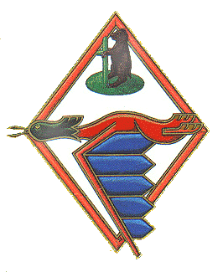

Commanders
28 Aug 1940 T. Rolski 18 Oct 1940 J. Orzechowski 12 Nov 1940 T. Rolski 1 July 1941 J. Zareba. 14 Aug 1941 J. Ostoja-Slonski 1 Sep 1941 H. Wczelik 14 Apr 1942 T. Czerwinski 22 Aug 1942 K. Rutkowski 14 Mar 1943 W. Karwowski 1 Jan 1944 S. Lapka 8 June 1944 J. Marciniak 28 June 1944 P. Niemiec 25 Sep 1944 J. Zulikowski 25 May 1945 J. Jeka 7 Jan 1946 T. Andersz
Stations
28 Aug 1940 Church Fenton ► 7 Nov 1940 Turnhill ► 3 Apr 1941 Northolt ► 7 Oct 1941 Speke ► 12 Dec 1941 Church Stanton ► 3 May 1942 Kirston in Lindsay ► 15 June 1942 Northolt ► 13 Mar 1943 Hutton Cranswick ► 30 Mar 1943 Catterick ►11 Auig 1943 Gravesend ►19 Aug 1943 Friston ► 22 Sep 1943 Heston ► 19 Dec 1943 Llanberd ► 1 Jan 1944 Heston ► 15 Mar 1944 Llanberd ► 20 Mar 1944 Heston ►1 Apr 1944 Coolham ► 22 Jun 1944 Ford ► 27 June 1944 Brenzett ► 10 July 1944 Andrewsfield ► 10 Oct 1944 Coltishall.
Aircraft
28 Aug 1940 Hurricane MkI and MkII 12 July 1941 Spitfire MkI and MkIIB 11 Dec 1941 Spitfire MkVB 29 Sep 1942 Spitfire MkIX 13 Mar 1943 Spitfire MkVB 26 Mar 1944 Mustang III
History
No. 306 Squadron was formed at Church Fenton on 28 August 1940, manned by Polish personnel and equipped with Hurricanes. It became operational on 8 September and moved to Northolt in April 1941 to take part in sweeps over northern France until October, when it was allocated to the defense of Merseyside. Spitfires replaced Hurricanes in July 1941 and in December the squadron moved to south-west England to undertake sweeps over north-west France. After a few weeks in Lincolnshire in May 1942, No.306 was back at Northolt for further sweeps until moving to Yorkshire in March 1944, converted to Mustangs. With these it helped cover the landings in Normandy, but was transferred soon afterwards to combating flying bombs over south-east England. In October 1944, the squadron moved to East Anglia for bomber escort duties, a task which it carried out until the end of the war. The squadron remained in fighter command until disbanded on 6 January 1947.
