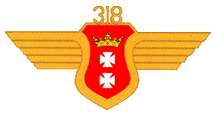

Commanders
S/Ldr Wojtyga Adam S/L L. Wielochowski S/Ldr Z. Moszynski S/Ldr W. Berezecki.
Locations
Sep 1943 Maquebilia (Palestine) ► Oct 1943 Gaza (Palestine) ► Dec 1943 Quassasin (Egypt) ► May 1944 Trigno (Italy) ► June 1944 St. Vito-Tortoretto-Fermo ► July 1944 Castigliore (Flight "A") ► Aug 1944 Falconara ► Sep 1944 Cassandra-Piagiolino-Rimini ► Oct 1944 Bellaria-Forli ► 1945 La Russia-Treviso-Risano (Udine)
Aircraft
6 June 1943 Hurricane MkIC 6 Sep 1943 Hurricane MkII 12 Mar 1944 Spitfire MkV Oct 1944 Spirfire MkIX.
History No 318 Squadron was formed at Delting on 20 March 1943 for tactical reconnaissance duties, and received Hurricanes for training purposes. In August the squadron left for the Middle East, where it took part in training with the Polish Army before leaving for Italy in April 1944. Now equipped with Spitfires, it flew ground attack and tactical reconnaissance missions in support of the 8th Army for the rest of the war. In August 1946 the squadron handed over its aircraft and left for the UK, where it disbanded on 31 August 1946.

