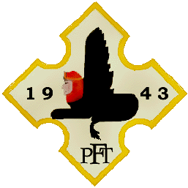

History
The Polish Fighting Team was a group of Polish pilots fighting on the North African front in 1943. The unit was sent to Africa on insistence of the Polish HQ, who wanted to train a cadre of experienced pilots in desert warfare and harsh African conditions.
Fifteen pilots were chosen, with a plan for personnel rotation every 3 months. After initial preparations at RAF West Kirby, they embarked on an Atlantic convoy, arriving in Africa in March 1943. High effectiveness and style very quickly earned them a "Skalski's Circus" nickname, after the first commander of the unit, Stanisław Skalski. Fyling Officer (por.) Mieczysław Wyszkowski was the only casualty in the PFT, shot down and taken Prisoner of War on April 18. The German Army in Africa surrendered on May 13 and the PFT was disbanded.

Locations
- March 13 1943 - Bu Grara
- April 11 1943- La Fauconnerie
- April 15 1943 - Goubrine
- May 6 1943- Hergla
- May 20 1943 - Ben Gardane

Squadron equipment
- March 15 1943- Supermarine Spitfire F VB Tropicalised and VC (inter alia: AB168, ER539 -7)
- March 23 - March 26 1943- Supermarine Spitfire F IXC (inter alia: EN261 -10, EN267 -5, EN268 -7, EN286 -8, EN300 -9, EN315 -6, EN361 -3, EN459 -1)
